назад

Задача 1
Условие | Решение
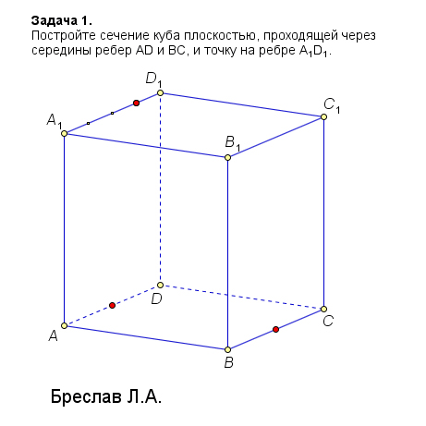 | 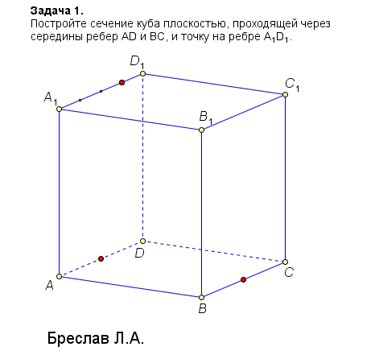
<iframe src='https://gfycat.com/ifr/GoodSarcasticEgret' frameborder='0' scrolling='no' width='640' height='606' allowfullscreen></iframe> <iframe src='https://gfycat.com/ifr/GoodSarcasticEgret' frameborder='0' scrolling='no' width='640' height='606' allowfullscreen></iframe>

